**GANPAT UNIVERSITY**

**Institute of Computer Technology**

**B. Tech. Computer Science and Engineering**

**SUBJECT:** IP

**NAME:** PILLAI MAYANK

**BATCH:** CSE-16

**ER NO:** CSE-70

**ER NO:** T24162581076

**Practical – 7**

**Exercises:**

1. **Write a HTML code to place different image formats on the webpage. Each image**

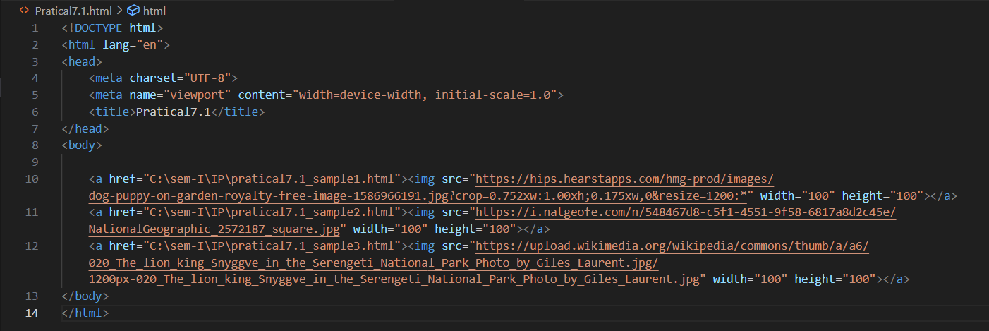 **link a related .html file which describes that image format.**

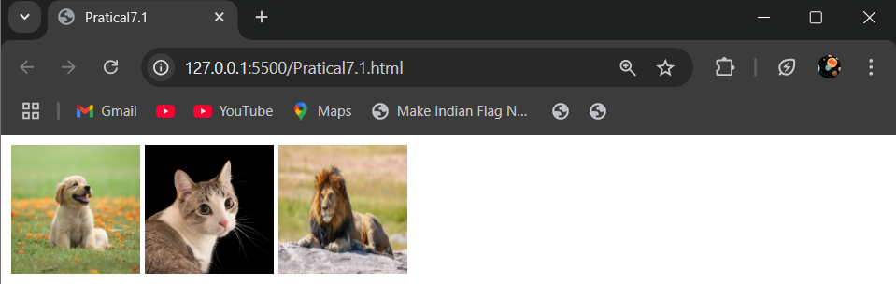**ANS:**

1. **Write a code for following output through <img> tag.**

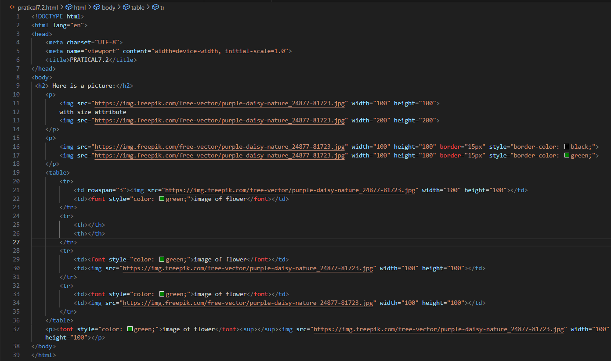**ANS:**

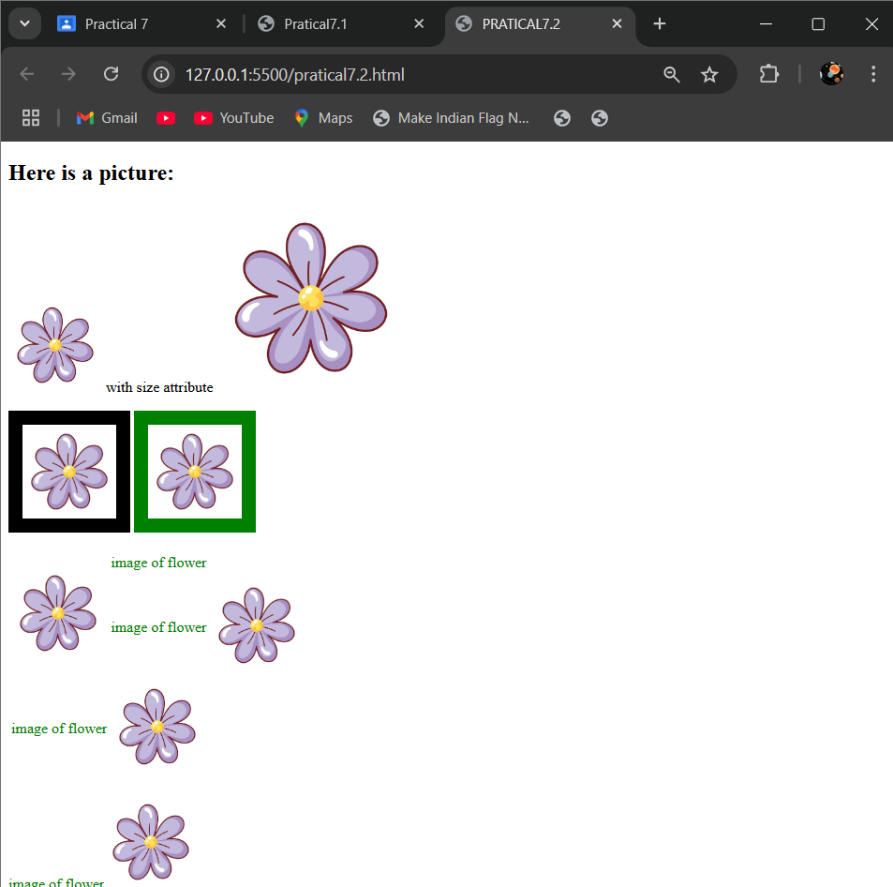

1. **Create a web page, which contain a table having three rows and three columns with proper heading and footer for Employee Information. Add caption "Employee Details" to a table.**

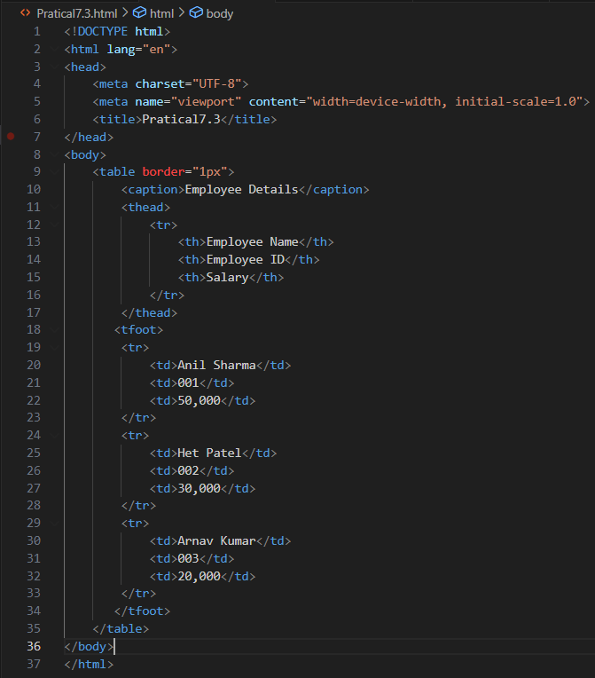**ANS:**

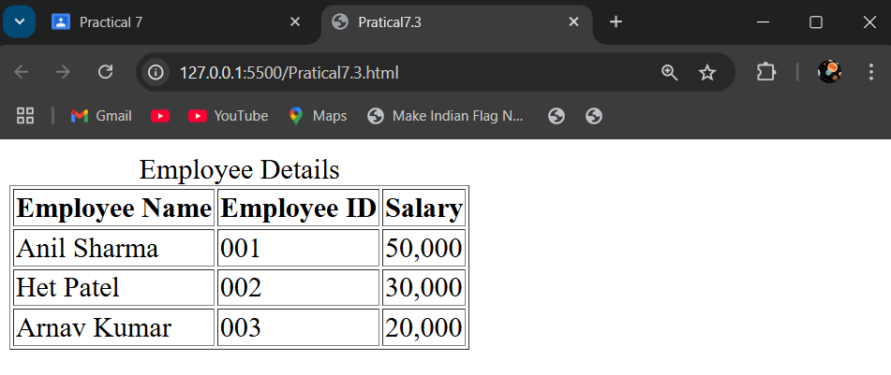

1. **Write a HTML code to create the following table in HTML with Dummy Data.**

**ANS:**

